**Ideation Phase**

**Define the Problem Statements**

|  |  |
| --- | --- |
| Date | 24 JUNE 2025 |
| Team ID | LTVIP2025TMID49893 |
| Project Name | Visualizing Housing Market Trends: Analysis Of Sale Prices And Feature Using Tableau |
| Maximum Marks | 4 Marks |

**Customer Problem Statement Template:**

Create a problem statement to understand your customer's point of view. The Customer Problem Statement template helps you focus on what matters to create experiences people will love.

A well-articulated customer problem statement allows you and your team to find the ideal solution for the challenges your customers face. Throughout the process, you’ll also be able to empathize with your customers, which helps you better understand how they perceive your product or service.

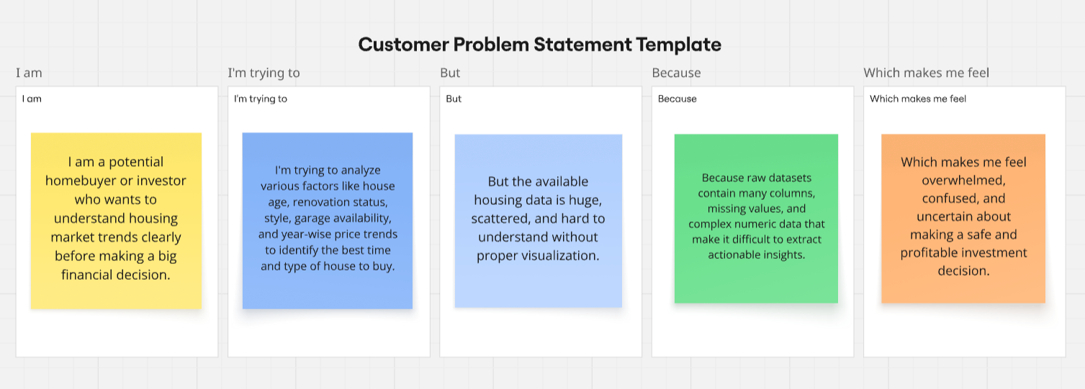

|  | **PS-1** | **PS-2** |
| --- | --- | --- |
| **I am (Customer)** | A prospective home buyer in India looking for my first house. | A real estate investor aiming to analyze property trends to maximize returns. |
| **I’m trying to** | Find a house that suits my budget, preferred style, and location while ensuring it is a good investment. | Identify which neighborhoods and house features have the best resale value over time. |
| **But** | There are too many options, and it's difficult to compare features like age, renovation status, and price trends clearly. | Historical price and renovation data are not easy to analyze together in one place. |
| **Because** | The housing market data is scattered, and visual analysis tools are lacking. | Current public reports and listings do not provide consolidated insights on market growth and feature trends. |
| **Which makes me feel** | Confused, overwhelmed, and unsure if I’m making the right choice. | Frustrated and hesitant to invest confidently without data-driven support. |